**Amazon 职位薪资与package参考**

[](http://www.jiuzhang.com/)

本资料由九章算法独家倾情整理

[www.jiuzhang.com](http://www.jiuzhang.com)

**目录**

1. Amazon 内部职级 (SDE) 2

2. Amazon各职位薪资情况 2

3. Amazon offer包裹参考 3

拿亚麻 offer 必备课程

《[面试软技能指导 - BQ/Resume/Project](https://www.jiuzhang.com/course/21/?utm_source=sc-libao-facebook)》《[九章算法班](https://www.jiuzhang.com/course/1/?utm_source=https:/www.jiuzhang.com/course/21/?utm_source=sc-libao-facebook)》《[⾯向对象设计OOD](https://www.jiuzhang.com/course/40/?utm_source=https:/www.jiuzhang.com/course/21/?utm_source=sc-libao-facebook)》

《[系统设计System Design](https://www.jiuzhang.com/course/28/?utm_source=https:/www.jiuzhang.com/course/21/?utm_source=sc-libao-facebook)》《[人工智能集训营](https://www.jiuzhang.com/course/20/?utm_source=https:/www.jiuzhang.com/course/21/?utm_source=sc-libao-facebook)》《[硅谷求职算法集训营](https://www.jiuzhang.com/course/29/?utm_source=https:/www.jiuzhang.com/course/21/?utm_source=sc-libao-facebook)》

## Amazon 内部职级 (SDE)

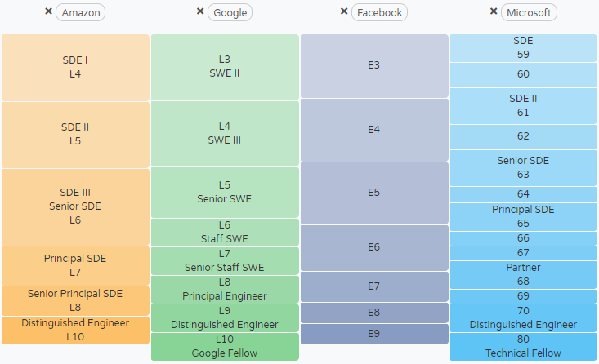

来源：levels.fyi

## 2. Amazon各职位薪资情况

|  |  |  |  |  |
| --- | --- | --- | --- | --- |
| **职级** | **Total** | **Salary** | **Stock(/yr)** | **Bonus** |
| SDE I | 155,214 | 117,098 | 16,422 | 21,694 |
| SDE II | 211,246 | 141,466 | 54,416 | 15,364 |
| SDE III | 310,523 | 158,077 | 140,946 | 11,500 |
| Principal SDE | 519,800 | 165,000 | 319,700 | 35,100 |
| L5 SDM | 240,893 | 154,243 | 82,007 | 4,643 |
| L6 SDM | 334,149 | 158,703 | 157,189 | 18,257 |
| Senior SDM | 544,260 | 166,652 | 303,130 | 74,478 |
| Product Manager | 160,657 | 109,712 | 47,063 | 3,882 |
| Senior PM | 230,415 | 142,939 | 69,061 | 18,415 |
| Principal PM | 393,650 | 160,900 | 177,750 | 55,000 |

## 3. Amazon offer包裹参考

